**Defer offscreen images**

May 2, 2019 • Updated May 29, 2020

Appears in: [Performance audits](https://web.dev/lighthouse-performance)

The Opportunities section of your Lighthouse report lists all offscreen or hidden images in your page along with the potential savings in [kibibytes (KiB)](https://en.wikipedia.org/wiki/Kibibyte). Consider lazy-loading these images after all critical resources have finished loading to lower [Time to Interactive](https://web.dev/interactive):

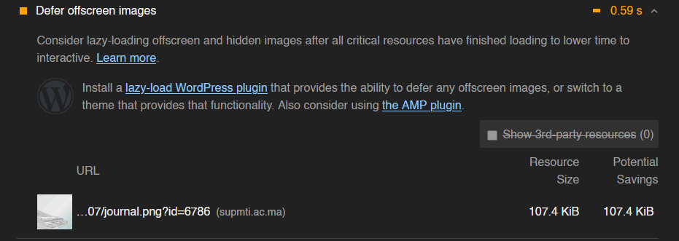

# Smush – Lazy Load Images, Optimize & Compress Images

**Optimize images, turn on lazy load, resize, compress & improve your Google Page Speed with the incredibly powerful and 100% free WordPress image smusher, brought to you by the superteam at WPMU DEV!**

And whether you spell it ‘optimise’ or ‘optimize’, Smush will compress images without a visible drop in quality.

Image optimization is the easiest way to make your site load super fast!